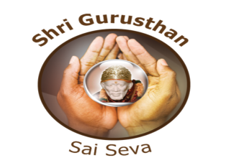
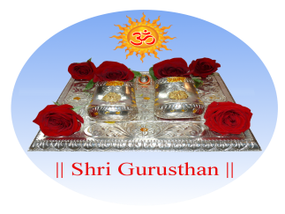

SHRI GURUSTHAN EVENT REGISTRATION
EVENT NAME – INDEPENDENCE DAY 2015
Saturday, August 15th, 10:30 AM – Noon

CONTACT NAME:
EMAIL:
PHONE NUMBER:
PERFORMANCE NAME:

NO. OF PARTICIPANT(S):
NAME OF PARTICIPANT(S):
DURATION IN MINUTES:
PROGRAM DETAILS:
ADDITIONAL DETAILS:

RULES & GUIDELINES:

- REGISTRATION WILL BE ACCEPTED FIRST COME FIRST SERVE
- PROGRAMS MAY BE SOLO OR GROUP
- SOLO PERFORMANCES WILL BE GIVEN 4 MINUTES, GROUPS of 3 or more WILL BE GIVEN 8 MINUTES.
- PATRIOTIC SONGS, DANCES, AND SKITS ARE PREFERRED
- REGISTRATIONS ARE DUE BY THURSDAY, 08/13/2015, 5:00 PM. EMAIL THIS FORM TO events@shrigurusthan.com
- IF YOUR PERFORMANCE NEEDS MUSIC, PLEASE SEND IN MP3 FORMAT BY 08/13/2015 TO events@shrigurusthan.com

JAI SAI RAM!

